- Explain how these 3 pegs are different (other than their color). Give an example of how 2 of them could be used:
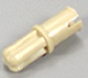 (color: tan)
 (color: blue)
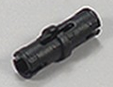 (color: black)
- Name this part, and describe 2 ways it can be used:


